Electricity Bill Management – Deliverable III

# User Manual

## Steps to execute project

Step 1. Download and install MySQL installer and NetBeans IDE 8.1 and setup java environment.

Step 2. Create a database with name 'cseb' and corresponding database tables by using "cseb.sql" file which is located at SETechFreak\cseb.sql

Step3. Add new System DSN for MySQL database with name 'cseb'. As illustrated below.

Go to control panel 🡪 Administrative tool and select ODBC Data sources.

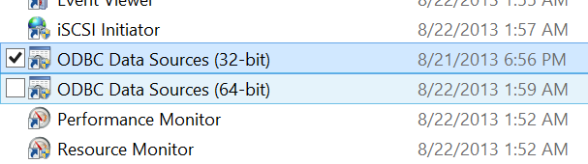

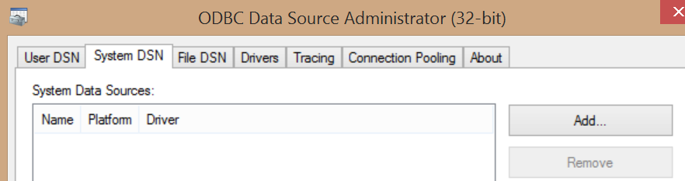

Select MySQL ODBC 5.3 ANSI Driver and click finish

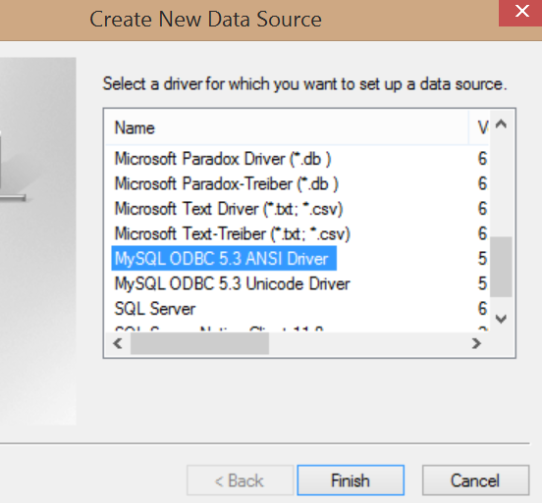

Then enter database server details as shown below and click OK

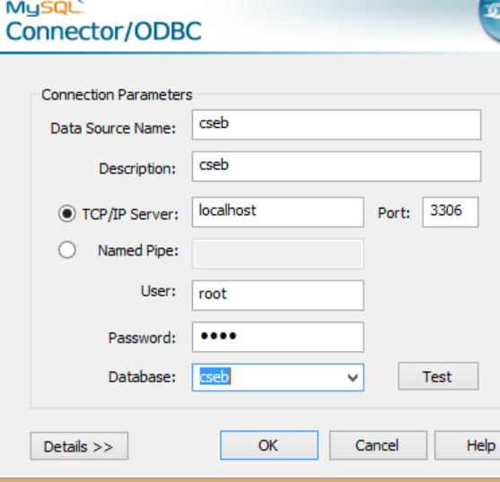

Step 4. Now that database has been set up, open net beans IDE and add new project by browsing to folder “cseb” by clicking on the add new project icon as show below.

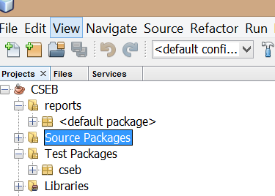

Step 5. After adding the project folder, right click on CSEB and then click Run to run the project.

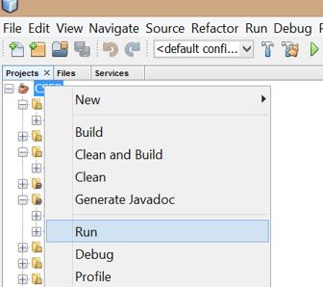

# Steps to navigate through application

## Step 1:

User must login to application using his/her user name and password.

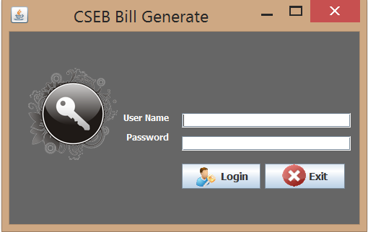

## Step 2

Select BILL MANAGEMENT from menu to set up the electricity billing rates and click SAVE button to update the information in the system (as shown below).

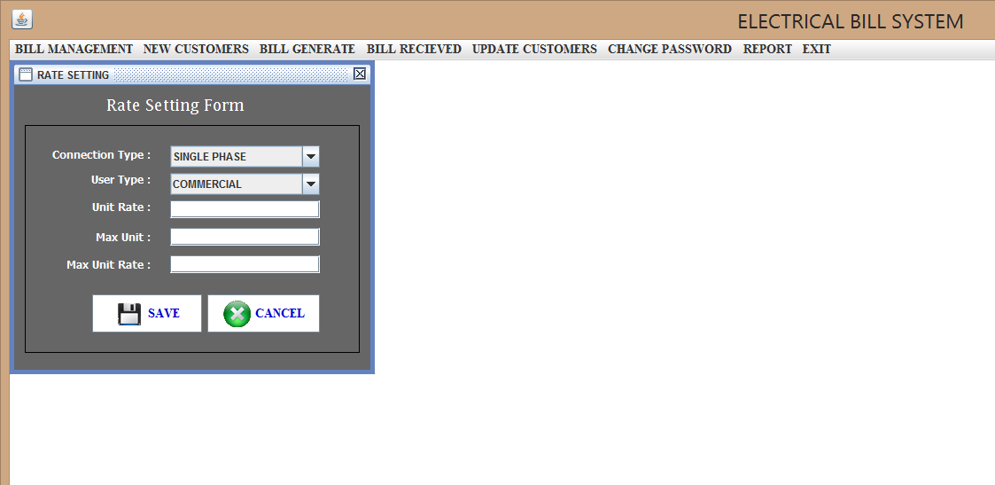

## Step 3

Select NEW CUSTOMERS from top menu to enter the personal details for new customer and click SAVE button to update the information in system.

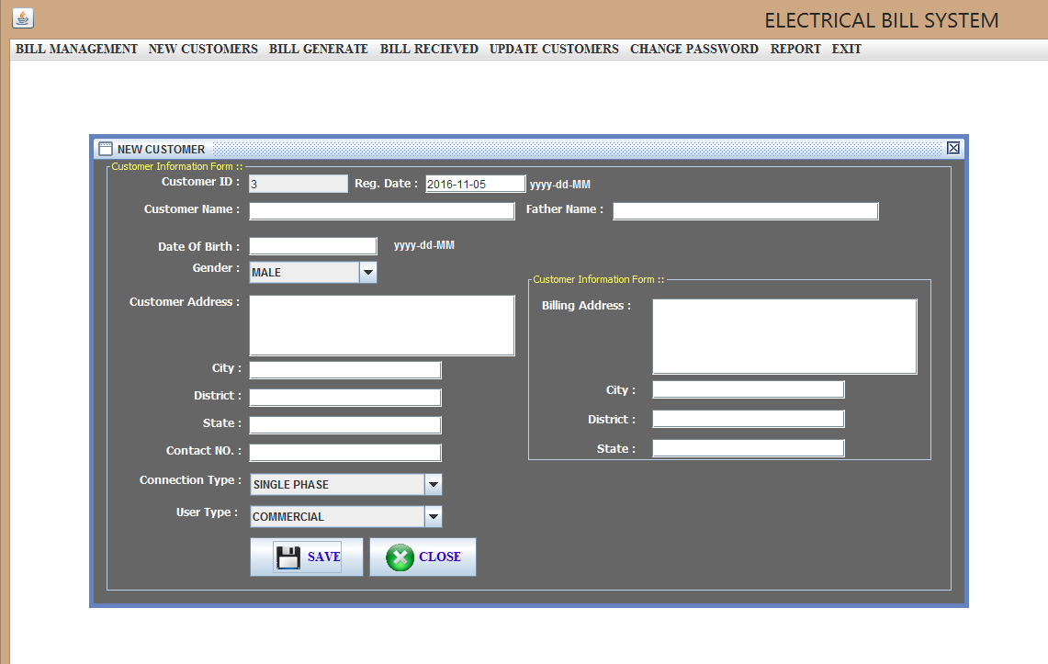

## Step 4

Select BILL GENERATE from top menu to enter the billing period and usage details of customer and click GENERATE button to save the data in system.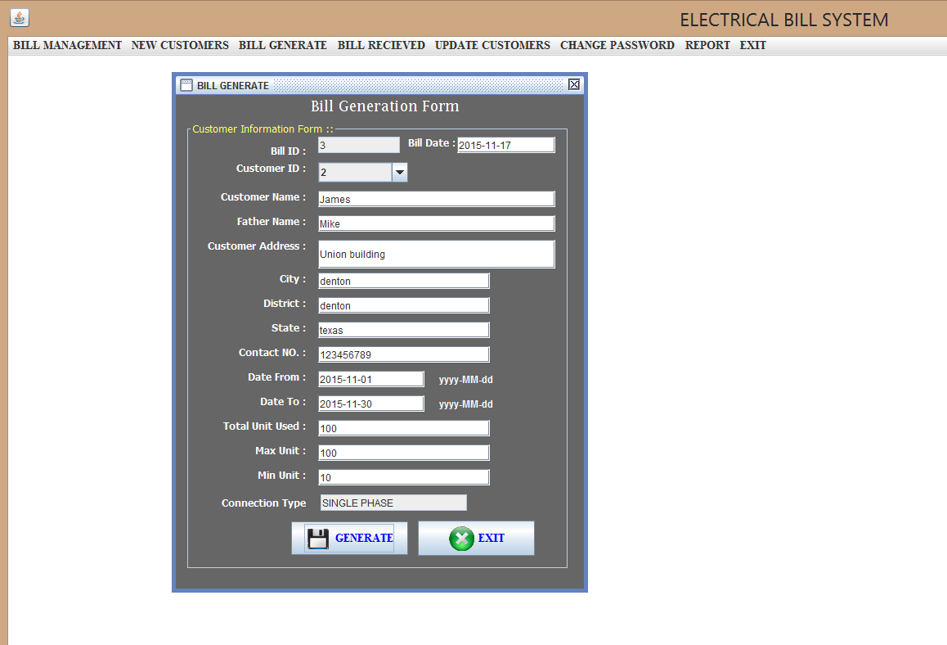

## Step 5

Select BILL RECEIVED from the top menu pane to get the due amount information and then after receiving the payment from customer click BILL PAID button to update the paid bill details in system.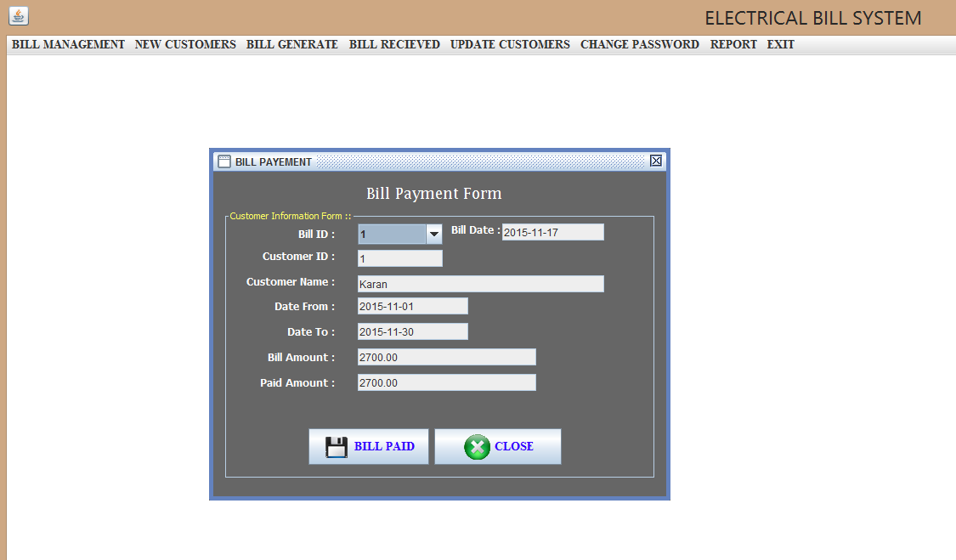

## Step 6

Select UPDATE CUSTOMERS from the top menu pane to update/delete customers record as shown below.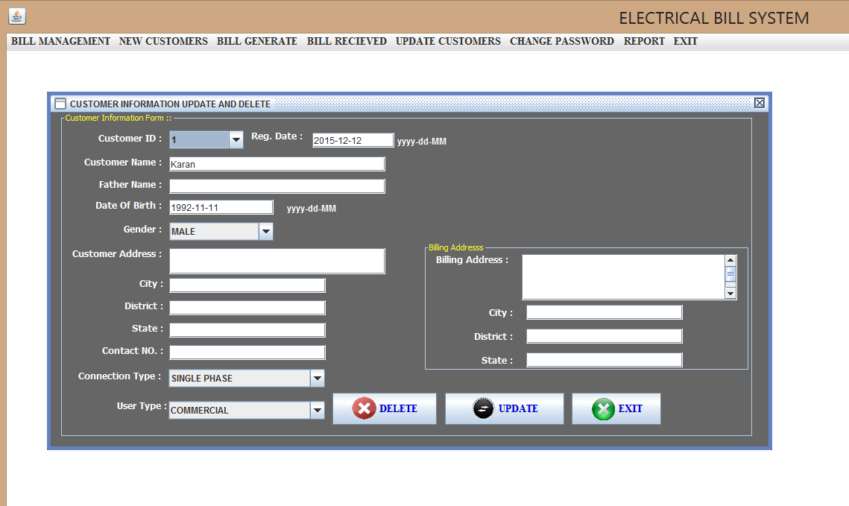

## Step 7

Select CHANGE PASSWORD from top menu pane to navigate to change password window. Enter your user name, old password and confirm new password and then click Login button to reset your login password, as shown below.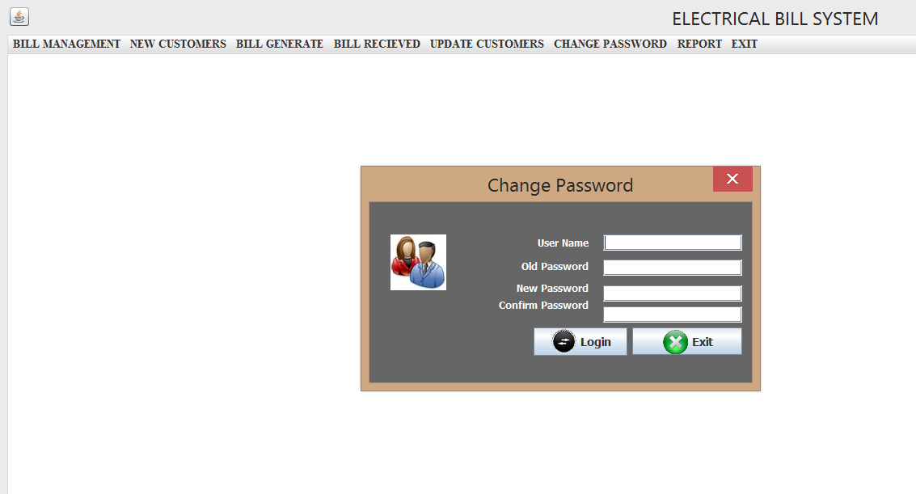

# Directions for compiling and running test cases.

Step 1. In net bean IDE, on the left project navigation pane expand Source Packages as shown below.

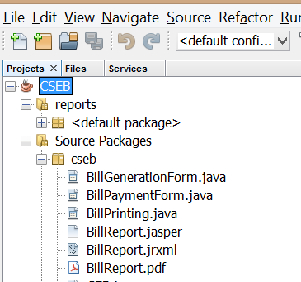

Step 2. Then select the java source code file for which Junit test needs to be performed and then navigate to top menu pane through tools 🡪 create/update test cases as shown below. 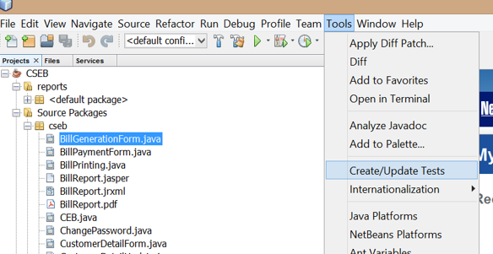

Step 3. Then in a popup window select framework as JUnit and click OK.

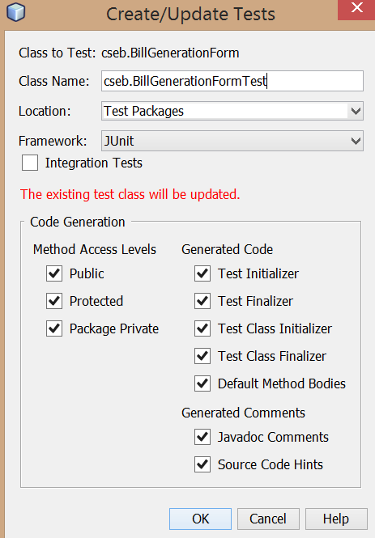

# Successfully implemented features and limitations

We were able to implement all the following features and functionality successfully.

1. User Login: this module enables secure login for users by authenticating them using their user names and password.
2. Bill Management: in this module user can set up electricity usage rates for their customers depending upon type of electricity connection.
3. New customer: this module allows users to enter personal details of customers and update the same in system.
4. Bill Generate: using this module users can generate the bill by entering the customers details along with billing period for which the bill needs to be generated.
5. Bill Received: this will present the users with customer’s due amount and can update the customers record accordingly after receiving the payment from customer.
6. Update Customers: this will allow users to update any personal information of customer.
7. Change Password: users can rest or update their login passwords.

However, during our first review of project design we were suggested to include yet another module that will allow users to get the bill report in pdf or printable form. We appreciated the idea and tried to implement the same. But this module doesn’t seem to be working properly due to some technical glitch. We will continue to work on this module during semesters break.

Next phase during our last group meeting we have identified how we will proceed about the next phase of project development. We came up with a plan to develop and enhance our project with new functionality that will allow even customers to register, view, request and pay electricity bill and also continue to fix the Bill Print module.

# Team Members roles and responsibility

Each team member has contributed equally towards the successful implementation of the project. Below are the modules list each member was responsible for.

* Alok Pal -Database designing

-User login functionality

-Customer detail update module

* Karanveer Singh -Rate setting module

-Customer detail module

-Password change module

* Yeshwanth Akarapu -Bill Printing Module

–Bill Payment Module

-Bill Generation Module

# 6. Meeting minutes

## 1. Call to order

Last meeting was held at willis library on 11-16-2015.

## Attendees

Attendees included Alok Pal, Karanveer Singh, Yeshwanth Akarapu.

## Agenda

* To track the project progress.
* To track the progress of every individual tasks assigned.

To discuss about any issues or challenges faced, if any.

## Reports

Final discussions regarding the presentation and deliverable III.

Discussions regarding proposal and plans for the next development phase.

## 2. Call to order

Meeting was held at discovery park library on 11-10-2015.

## Attendees

Attendees included Alok Pal, Karanveer Singh, Yeshwanth Akarapu.

## Agenda

* To track the project progress.
* To track the progress of every individual tasks assigned.
* To discuss about any issues or challenges faced, if any.

## Reports

AP: fix some database connectivity issues

KS, AP, YA to start applying JUnit testing to their respective modules.

## 3. Call to order

Second meeting held at discovery park library on 11-01-2015.

## Attendees

Attendees included Alok Pal, Karanveer Singh, Yeshwanth Akarapu.

## Agenda

* To track the project progress.
* To track the progress of every individual tasks assigned.
* To discuss about any issues or challenges faced, if any.

## Reports

AP: Connect whole project to database and check by entering dummy values.

## 4. Call to order

A meeting of Team TechFreak was held at Willis library on 10-02-2015.

## Attendees

Attendees included Alok Pal, Karanveer Singh, Yeshwanth Akarapu.

## Agenda

* To track the project progress.
* To track the progress of every individual tasks assigned.
* To discuss about any issues or challenges faced, if any.
* To discuss about design and implementation of security features.
* Setting up new milestones.

## Reports

YA: facing challenge with design considerations for home screen.

KS: facing challenge in acquiring connection with database server.